

MATHEMATICS: SPECIALIST 3CMAS/3DMAS SAMPLE EXAMINATION
RESOURCE-RICH

Section 7 of the New WACE Manual: General Information 2006–2009 outlines the policy on WACE examinations.

Further information about the WACE Examinations policy can be accessed from the Curriculum Council website at http://newwace.curriculum.wa.edu.au/pages/about_wace_manual.asp

The purpose for providing a sample examination is to provide teachers with an example of how the course will be examined. Further fine tuning will be made to this sample in 2007 by the examination panel following consultation with teachers, measurement specialists and advice from the Assessment, Review and Moderation (ARM) panel.

The examination is in two parts, in line with recommendations of the ARM panel--a resource-free examination of 50 minutes, worth 40 marks, and a resource-rich examination of 100 minutes, worth 80 marks. CAS (Computer Algebra System) calculators are excluded in the resource-free part and included in the resource-rich part.
0000.doc





Western Australian Certificate of Education, Sample External Examination
Question/Answer Booklet

MATHEMATICS: SPECIALIST
Please place one of your student identification labels in this box.
3CMAS/3DMAS
WRITTEN PAPER
RESOURCE-RICH

Student Number: In figures

In words

Time allowed for this paper
Reading time before commencing work: Ten minutes
Working time for paper: One hour and forty minutes

Material required/recommended for this paper

To be completed by candidates

What kind(s) of calculator did you bring to this examination?

Make and model:
1.

2.
None  (tick if applicable)

To be provided by the supervisor
This Question/Answer Booklet

To be provided by the candidate
Standard items: Pens, pencils, eraser, correction fluid, ruler,
highlighter

Special items: Curriculum Council Mathematical Formulae and Statistical Tables Book, drawing instruments, templates, notes on TWO unfolded sheets of A4 paper and calculators satisfying the conditions set by the Curriculum Council for this subject.
Note: Personal copies of the Tables Book should not contain any handwritten or typewritten notes, symbols, signs, formulae or any other marks (including underlining and highlighting) except a name and address, and may be inspected during the examination.

Important note to candidates
No other items may be taken into the examination room. It is your responsibility to ensure that you do not have any unauthorised notes or other items of a non-personal nature in the examination room. If you have any unauthorised material with you, hand it to the supervisor before reading any further.

This paper is for students who have completed Units 3CMAS and 3DMAS as their last pair of units.
Structure of this paper

Working time | Number of questions available | Number of questions to be attempted | Marks
1 hour  40 minutes | 11 | 11 | 80
 |  | [Total marks] | 80

This paper has ELEVEN (11) questions. Attempt ALL questions.

Question | Marks
1 | 5
2 | 6
3 | 5
4 | 8
5 | 7
6 | 9
7 | 7
8 | 5
9 | 6
10 | 12
11 | 10
Total marks | 80

Instructions to candidates

1. The rules for the conduct of Curriculum Council examinations are detailed in the Student Information Handbook. Sitting this examination implies that you agree to abide by these rules.

2. Write your answers in the spaces provided in this Question/Answer Booklet. Spare pages may be found at the end of the booklet. If you need to use them, indicate in the original answer space where the answer is continued (i.e. give the page number).

3. A blue or black ballpoint or ink pen should be used.

4. It is recommended that you do not use pencil except in diagrams.

5. Show all your working clearly. Your working should be in sufficient detail to allow your answers to be checked readily and for marks to be awarded for reasoning. Correct answers given without supporting reasoning may not be allocated full marks. Incorrect answers given without supporting reasoning cannot be allocated any marks. If you repeat an answer to any question, ensure that you cancel the answer you do not wish to have marked

6. On the front cover you are asked to state the kinds of calculator that you brought into the examination. This information is required to ensure the examination is fair for all students. Please complete the box. Note that the same marking procedure will apply to all scripts, whatever calculator you use.

THIS PAGE HAS BEEN LEFT BLANK INTENTIONALLY

RESOURCE-RICH

This paper has ELEVEN (11) questions. Attempt ALL questions.

Question 1 [5 marks]
If 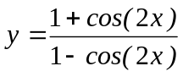, show that 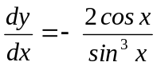.

Question 2 [6 marks]
Given the following expression 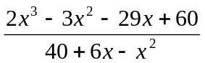

- Simplify the expression.
[2 marks]

- For which value(s) of x, if any, is the original expression not defined.
[2 marks]

- Compare the original expression and its simplified version. Are there any values of x, where these two expressions are unequal? Explain your answer.
[2 marks]

Question 3 [5 marks]
The diagram below shows the polar graphs of r = k and r = nθ (n an integer).
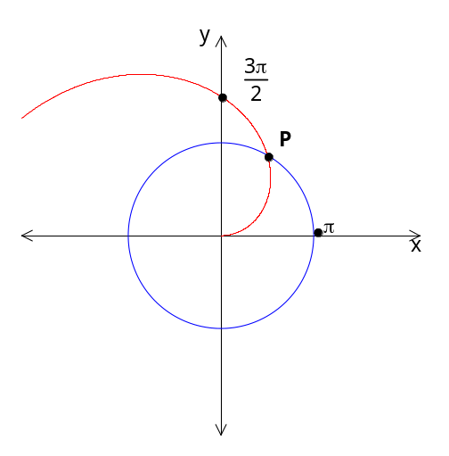Also, the point of intersection of these two graphs is point P.

- Write down the values of k and n.
[2 marks]

- Determine, exactly, the Cartesian coordinates of point P.
[3 marks]

THIS SPACE HAS BEEN LEFT BLANK INTENTIONALLY

Question 4 [8 marks]
- 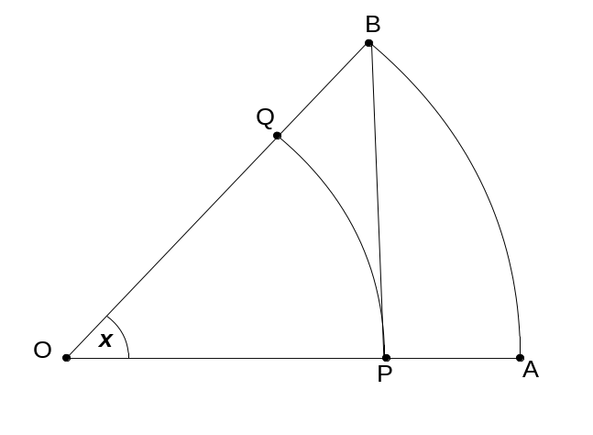Two circles with centre O have arcs AB and PQ, of radii 1 and respectively, which subtend an angle of radians at O (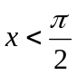). The straight lines AP and PB are perpendicular.

By comparing:
- the areas of sector OPQ and triangle OPB and
- the lengths of PB and arc AB,

or otherwise, establish the inequalities 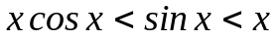.
[4 marks]

- Explain why the above result shows that 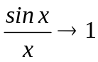 as  and hence, determine 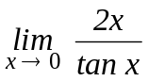.
[4 marks]

Question 5 [7 marks]
Andrea and Brenda are flying their toy aircraft. The initial position vectors relative to the centre of the flying field are:
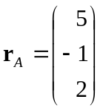 metres and 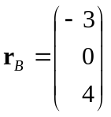 metres.

They start flying at the same time with velocities:
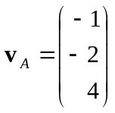m/s and 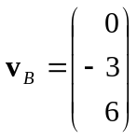 m/s, respectively.

Calculate the minimum distance they are apart and the time when the location of the minimum distance is reached after the aircraft leave their initial positions.
[7 marks]

Question 6 [9 marks]
The mass M(t) grams of a radioactive decaying substance after t years satisfies:
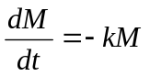, where k is a positive constant.
After 2 years the mass of the substance is 150 grams and after 3.5 years it has decayed to 100 grams.
- Show that 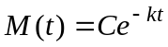 satisfies the differential equation for any constant C.
[2 marks]

- Find k and C.
[3 marks]

- How long will it take for the mass of the substance to reduce to 40 grams?
[2 marks]

- Find the radioactive half-life of the substance.
[2 marks]

Question 7 [7 marks]
Consider the curve 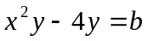 where b is a real value.

- Determine the equation of the tangent line to this curve at the point (x₁, y₁).
[4 marks]

- What is the restriction on b so that the curve has a vertical tangent line at the point (x₁, y₁
[3 marks]

Question 8 [5 marks]
Solve the inequality 1 < | 5 – 3x | < 9 algebraically.
[5 marks]

Question 9 [6 marks]
Use a vector method to prove that the mid-points of the sides of a quadrilateral form a parallelogram.
[6 marks]

Question 10 [12 marks]
- Suppose that z is a complex number with modulus r and argument .

Express in terms of r and the modulus and argument of each of the complex numbers 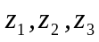 and 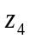, where:
  - 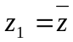
[2 marks]

  - 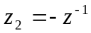
[3 marks]

  - 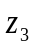 and are the square roots of z.
[3 marks]

- The diagram below shows the unit circle in the complex plane and the position of the complex number, z whose modulus r is estimated as 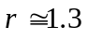 and whose argument is estimated as 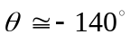. Indicate, as precisely as you can, (on the diagram below) the locations of the complex numbers 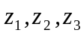 and 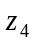, as defined in part (a).
[4 marks]

Im z

i

-1 1
Re z

z

-i

Question 11 [10 marks]
The females of a herd of wild goats living in the North West of Western Australia have the following reproductive rates, which can be modelled using Leslie matrices.

Suppose the females are divided into four categories: kids (younger than 1 year); yearlings (1 to 2 years); adults (over 2 and under 3 years); and old goats (3 years or older). Only adult and old goats are fertile. On average, every 100 adults give birth to 120 (female) kids for the next generation. However, every 100 three year old goats only give birth to 50 kids. For these females, 65% of kids survive to become yearlings, 70% of yearlings survive to become adults whilst 80% of adults survive to become old goats. Sadly, old goats which live beyond three years, become infertile and eventually die.

Let 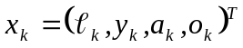 where the entries in 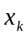 give the number of females in each age group in year k.

Leslie matrix L, to show the transition from one generation to the next is:
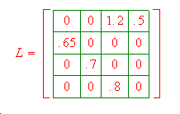
- If initially there are 150 kids, 200 yearlings, 200 adults and 80 old goats, what is the distribution after 20 years?
[3 marks]

- Find the net reproduction rate of the population of female goats.
[3 marks]

- Assuming there are enough male goats to fulfil their part, will this population of female goats become stable over time (that is, survive in the long run)?
[4 marks]

ACKNOWLEDGEMENTS

Published by the Curriculum Council of Western Australia
27 Walters Drive
OSBORNE PARK WA 6017

